Problem statements:

Problem n: Reasoning for Claims engine prediction
Empower Claim owners with clear reasoning behind the Claim Priority/Risk Score by leveraging Claim Prediction Engine (show them HOW the model reached the score)
Business Value:
- Confidently adopt Claim Prediction Engine to prioritize claims supported by clear data
- Provide additional supplementary information on How the score was reached
Success Metrics:

Problem 2: Recommend best health care program
Help Claim owners identify the most suitable referral for MH claims using Agentic AI to guide decision support, via natural language.
Business Value:
- Clarify claim context from overlapping services
- Surface most relevant healthcare programs for the specific claim
Success Metrics: @Dutta, Abhijit @Dodani, Khushboo
- Agent AI consistently recommends healthcare programs aligned with claim owner decisions or approved guidelines (e.g., 80%+ agreement rate with SME-reviewed cases).
- Low false positive/negative rate in recommendations, minimizing inappropriate referrals.
- Agentic AI accurately parses and summarizes claim context, distinguishing between overlapping services and identifying key factors (e.g., chronicity, comorbidities, prior program use).
- Agentic AI can extract relevant unstructured data from medical notes, history, and case narratives.
- Claim owners can interact with the AI via simple, natural language prompts (e.g., “What are the best options for this claim?”).
- System responds in clear, actionable language, reducing training time for claim owners.
- Measure reduction in time spent by claim owners in researching referral options (e.g., X% faster decision-making time).
- Positive user feedback on AI reducing cognitive load.
- Seamless integration with claim systems (CMS or equivalents) without disrupting current workflows.
- Easy access via existing claim management tools or portals.
- Improved claim processing efficiency (e.g., reduced open duration for MH claims).
- Potential reduction in repeat referrals or inappropriate program placements.
- Better claimant outcomes tracked via downstream metrics (e.g., reduced time on claim, improved return-to-work rates).

Problem 3: On demand chat based access to Claims data
Enable Claim owners to chat with an agent for real-time clarification on complex claim details
Business Value:
Accelerate claim resolution by reducing back-and-forth and improving understanding through instant, guided support

Problem 4: Democratized access to Claim information for future Agentic projects
Introduce a claim specific MCP server using Microsoft Azure MCP service that will introduce context rich access to most public and private

Elevator Pitch: Smarter Referrals, Stronger Recovery
Referral Radar is your intelligent assistant — scanning claim data for hidden mental health signals and helping case managers make faster, more confident decisions

OPEN Questions
- Can we identify missing documents that could further help improve the healthcare program recommendation so that the claims owner can ask for these specific documents and intelligence ?

- C.....

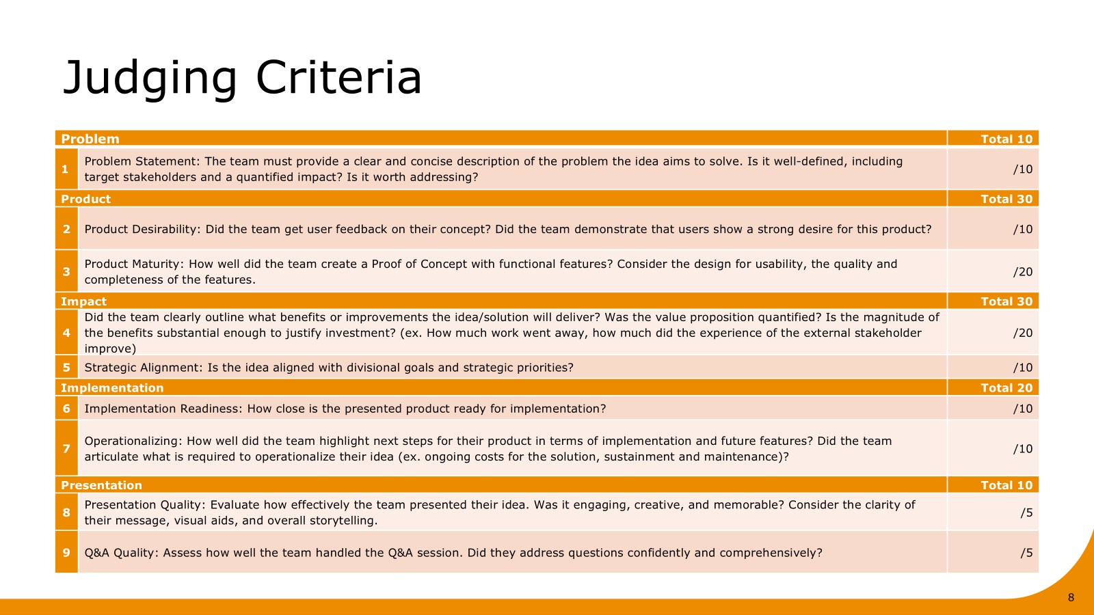

Problem
- Problem Statement: The team must provide a clear and concise description of the problem the idea aims to solve. Is it well-defined, including target stakeholders and a quantified impact? Is it worth addressing?

Claim owners face two key barriers to making timely, appropriate mental health (MH) referrals:
- Lack of decision support: Critical context—such as red flags, comorbidities, and prior history—is buried in unstructured data, making it difficult to assess referral needs quickly. The goal to identify mental health referrals earlier on to guide early intervention.
  - Insights, Summary
  - Chronological display of documentation
  - Mind map, Chatbot?

- Unclear program fit: Even when MH needs are identified, overlapping services and inconsistent guidance make it hard to match claims to the most appropriate healthcare programs—leading to delays, repeat referrals, and higher costs. The goal is to identify appropriate mental health programs for injured workers.

- Can we predict accurately with the existing mental health options
- Business vision - Scale from 4 programs to X programs,

Product
- Product Desirability: Did the team get user feedback on their concept? Did the team demonstrate that users show a strong desire for this product?
- Product Maturity: How well did the team create a Minimum Viable Product (MVP) with functional features? Consider the design for usability, the quality and completeness of the features.
Product
Referral Radar is your intelligent assistant — scanning claim data for hidden mental health signals and helping case managers make faster, more confident recommendations
Features
- Claims AI agent (user facing)
  - Extractor - Agentic AI can extract relevant unstructured data from medical notes, history, and case narratives.
  - Parser - Agentic AI accurately parses and summarizes claim context, distinguishing between overlapping services and identifying key factors (e.g., chronicity, comorbidities, prior to program use).
  - Chat agent that enables case managers to chat with an agent for real-time clarification on complex claim details
  - Recommender - Agent AI consistently recommends healthcare programs aligned with claim owner decisions or approved guidelines (e.g., 80%+ agreement rate with SME-reviewed cases).
  - Seamless integration with claim systems (CMS or equivalents) without disrupting current workflows.
- MCP server (technical advancement)
  - Claims and Procedure MCP: The MCP (Model Context Protocol) server acts as a domain-specific middleware layer that consolidates APIs and document resources related to claims, enabling agentic applications to access claim data efficiently without custom integrations for each agent.
  - Scalability and Extendibility : It provides a standardized interface for agents to retrieve, process, and reason over claim-related information, supporting multi-agent frameworks and future extensibility. 2
  - Security and Governance: The MCP server enhances security and governance by centralizing access control, allowing fine-grained permissions for different teams or agents.

Impact
- Value Proposition: Did the team clearly outline what benefits or improvements the idea/solution will deliver? Was the value proposition quantified? Is the value substantial enough to justify investment? (ex. Does the idea move the needle in optimizing our internal ITAP operations?)
- Strategic Alignment: Is the idea aligned with divisional goals and strategic priorities?
Impact statements
- Reduction in average time to make referral decisions (parsing information)
- Decrease in open claim duration for MH cases
- Reduction in inappropriate or repeat referrals
- CO satisfaction/ trust score for recommended programs
- Reduced workload for clinical advisors or escalation teams
- Days between claim acceptance and first referral
- RTW rates
Implementation
- Implementation Readiness: How close is the presented product ready for implementation?
- Operationalizing: How well did the team highlight next steps for their product in terms of implementation and future features? Did the team articulate what is required to operationalize their idea (ex. ongoing costs for the solution, sustainment and maintenance)?

Future features
- Identify missing documents that could further help improve the healthcare program recommendations.
- Empower case managers with clear reasoning behind the Claim Priority/Risk Score by leveraging Claims Prediction Engine (show them HOW the model reached the score). Our hypothesis is that this will help mitigate risks of adoption.

Roadblocks to implementation

Presentation
- Presentation Quality: Evaluate how effectively the team presented their idea. Was it engaging, creative, and memorable? Consider the clarity of their message, visual aids, and overall storytelling.
- Q&A Quality: Assess how well the team handled the Q&A session. Did they address questions confidently and comprehensively?

Slide Flow:

Intro and Problem statement
MH stats/MH policy and outlook as a societal trend
Use of claim cost duration
CM workflow and numbers (300 CM up to 200 files on desk)- what numbers are missing- (how long does a claim review take? How much time are we saving them?
Outcome (longer tx/higher cost/poor provider and worker experience) Add stats on early tx and outcomes
(for myself coming at it from a clinician perspective I have years of seeing this in place etc..)

Solution
Building on existing work from Diego(name of that tool?)
Impact
Building on existing workflow and work being done
Early identification/more accurate referrals to hcp
FTE savings in CM times(rough calculation)
Ease of CM role
Keeping people work for people(CM feedback note) reduced admin burden
Reduced claims cost as improved referral timelines
Scaleability to all conditions and referrals organizational impact

Stats:

- Problem statement - 1 min (jasper)
- Product desirability - 1 min (jasper)
- Impact (jasper) - 2 mins
  - strategic alignment
  - quantifiable business value
- Product & implementation (bilal) - 4mins
  - UI
  - Agent trace
  - Architecture & implementation readiness
- Value proposition round up - 1 min (khush)
- Implementation readiness
- Operationalizing/ next steps - 1 min (aditya)

